EXP:2 For a given set of training data examples stored in a .CSV file, implement and demonstrate the Candidate-Elimination algorithm in python to output a description of the set of all hypotheses consistent with the training examples

Aim
To implement the Candidate-Elimination algorithm in Python using a CSV file and determine the set of all hypotheses consistent.
Algorithm
- Read the training dataset from a CSV file.
- Initialize S with the first positive example.
- Initialize G with all '?'.
- For each training example:
  - If positive:
    - Generalize S.
    - Remove inconsistent hypotheses from G.
  - If negative:
    - Specialize G.
- Display the final S and G boundaries.

CODE
import pandas as pd
import numpy as np

# Read training data
data = pd.read_csv("trainingdata.csv")

concepts = np.array(data.iloc[:, :-1])
target = np.array(data.iloc[:, -1])

# Initialize Specific Hypothesis
specific_h = concepts[0].copy()

# Initialize General Hypothesis
general_h = [["?" for i in range(len(specific_h))]
for i in range(len(specific_h))]

print("Initial Specific Hypothesis:")
print(specific_h)

print("\nInitial General Hypothesis:")
print(general_h)

for i, h in enumerate(concepts):

if target[i] == "Yes":

for x in range(len(specific_h)):
if h[x] != specific_h[x]:
specific_h[x] = '?'
general_h[x][x] = '?'

if target[i] == "No":

for x in range(len(specific_h)):
if h[x] != specific_h[x]:
general_h[x][x] = specific_h[x]
else:
general_h[x][x] = '?'

print("\nFinal Specific Hypothesis:")
print(specific_h)

print("\nFinal General Hypothesis:")

general_final = []

for row in general_h:
if row != ['?' for i in range(len(specific_h))]:
general_final.append(row)

for row in general_final:
print(row)
OUTPUT
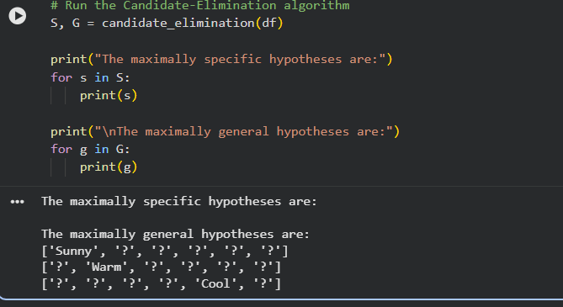

Result
The Candidate-Elimination algorithm was successfully implemented using a CSV dataset. The algorithm computed the Specific Boundary (S) and the General Boundary (G).

